**Programs**

I installed Arduino for programming Arduino Uno. I installed VNC Viewer for connection to the Raspberry PI 3.

**Arduino Uno Code**

//include required libraries and variables

#include <Wire.h>

#include <Adafruit_PWMServoDriver.h>

Adafruit_PWMServoDriver pwm = Adafruit_PWMServoDriver();

#define SERVOMIN 125

#define SERVOMAX 575

#define echoPin 5

#define trigPin 6

char dataIn = 'E'; char determinant; char det; int adim=80; int adim4,adim3=0; int adim2=10;

const int pinileri = 12; const int pingeri =4; const int pinsol = 7; const int pinsag = 13;

int maximumRange = 50;

int minimumRange = 0;

void setup() {

Serial.begin(9600); // sets the baud rate for serial data communication.

// Configures the specified pin to behave either as an input or an output.

pinMode(trigPin, OUTPUT);

pinMode(echoPin, INPUT);

// Pulse Width Modulation, or PWM, is a technique for getting analog results with digital means. I setup it with 60 frequency.

pwm.begin();

pwm.setPWMFreq(60);

}

void loop() {

int olcum = mesafe(maximumRange, minimumRange); // calculate distance

Serial.print("olcum: "); Serial.println(olcum);

det = check(); // control of movement

while (det == 'O') // for example if user click button which reference ‘O’ check() function will start.

{

det= check();

}

while (det == 'P')

{

det= check();

}

while (det == 'K')

{

det= check();

}

while (det == 'N')

{

det= check();

}

while (det == 'B') //BACK

{

// digitalWrite() is used to write a HIGH or a LOW value to a digital pin.

digitalWrite(pingeri, HIGH);

digitalWrite(pinsol, HIGH);

det = check();

}

while (det == 'S')

{

digitalWrite(pinileri, LOW);

digitalWrite(pingeri, LOW);

digitalWrite(pinsol, LOW);

digitalWrite(pinsag, LOW);

det = check();

}

int olcum2;

if(olcum>25 || olcum==0) // robot can run between 0 – 25cm.

{

det = check();

while (det == 'F' && (olcum>10 || olcum==0)) //FORWARD

{

olcum2 = mesafe(maximumRange, minimumRange);

digitalWrite(pinileri, HIGH);

digitalWrite(pinsag, HIGH);

det = check();

if(olcum2<25)

{

break;

}

}

while (det == 'L') //LEFT

{

olcum2 = mesafe(maximumRange, minimumRange);

digitalWrite(pinileri, HIGH);

digitalWrite(pinsol, LOW);

det = check();

if(olcum2<25)

{

break;

}

}

while (det == 'R') //RIGHT

{

olcum2 = mesafe(maximumRange, minimumRange);

digitalWrite(pingeri, LOW);

digitalWrite(pinsag, HIGH);

det = check();

if(olcum2<25)

{

break;

}

}

}

else

{

digitalWrite(pinileri, LOW);

digitalWrite(pingeri, LOW);

digitalWrite(pinsol, LOW);

digitalWrite(pinsag, LOW);

}

}

int mesafe(int maxrange, int minrange)

{

long duration, distance;

digitalWrite(trigPin,LOW);

delayMicroseconds(2); // provide delay for healthy calculate of distance

digitalWrite(trigPin, HIGH);

delayMicroseconds(10);

digitalWrite(trigPin, LOW);

duration = pulseIn(echoPin, HIGH); // Reads a pulse on a pin. For example, if value is HIGH , pulseIn() waits for the pin to go from LOW to HIGH , starts timing, then waits for the pin to go LOW and stops timing.

distance = duration / 58.2;

delay(40);

if(distance >= maxrange || distance <= minrange)

return 0;

return distance;

}

int check()

{

if (Serial.available() >0) //SERIAL PORT CHECK

{

dataIn = Serial.read(); // reads input from serial data

if (dataIn == 'O') // UP

{

determinant = 'O';

if(adim <161 ) // range of motion amount

{

adim=adim+10; // amount of movement

Serial.print("servo 1 det: "); Serial.println(determinant);

Serial.print("adim: ");Serial.println(adim);

pwm.setPWM(0, 0, angleToPulse5(adim)); // movement of engine ( first value is motor number, second value start point and last one is movement function of engine)

delay(300);

}

else{

adim=90;

Serial.print("servo 1 det: "); Serial.println(determinant);

Serial.print("adim: ");Serial.println(adim);

pwm.setPWM(0, 0, angleToPulse6(adim));

delay(300);

}

}

else if (dataIn == 'P') // GRASP

{

determinant = 'P';

if(adim2 <51 )

{

adim2=adim2+10;

Serial.print("servo 3 det: "); Serial.println(determinant);

Serial.print("adim2: ");Serial.println(adim2);

pwm.setPWM(2, 0, angleToPulse(adim2));

delay(300);

}

else{

adim2=10;

Serial.print("servo 3 det: "); Serial.println(determinant);

Serial.print("adim2: ");Serial.println(adim2);

pwm.setPWM(2, 0, angleToPulse2(adim2));

delay(300);

}

}

else if (dataIn == 'N') // DOWN

{

determinant = 'N';

if(adim4 <81 )

{

adim4=adim4+10;

Serial.print("servo 4 det: "); Serial.println(determinant);

Serial.print("adim4: ");Serial.println(adim4);

pwm.setPWM(1, 0, angleToPulse7(adim4));

delay(300);

}

else{

adim4=10;

Serial.print("servo 4 det: "); Serial.println(determinant);

Serial.print("adim4: ");Serial.println(adim4);

pwm.setPWM(1, 0, angleToPulse8(adim4));

delay(300);

}

}

else if (dataIn == 'K') // CENTRE

{

determinant = 'K';

if(adim3 <81 )

{

adim3=adim3+10;

Serial.print("servo 2 det: "); Serial.println(determinant);

Serial.print("adim3: ");Serial.println(adim3);

pwm.setPWM(3, 0, angleToPulse3(adim3));

delay(300);

}

else{

adim3=0;

Serial.print("servo 2 det: "); Serial.println(determinant);

Serial.print("adim3: ");Serial.println(adim3);

pwm.setPWM(3, 0, angleToPulse4(adim3));

delay(300);

}

}

else if (dataIn == 'F')

{

determinant = 'F';

Serial.println(determinant);

}

else if (dataIn == 'B')

{

determinant = 'B';

Serial.println(determinant);

}

else if (dataIn == 'L')

{

determinant = 'L';

Serial.println(determinant);

}

else if (dataIn == 'R')

{

determinant = 'R';

Serial.println(determinant);

}

else if (dataIn == 'S')

{

determinant = 'S';

Serial.println(determinant);

}

}

return determinant;

}

int angleToPulse(int ang){

int pulse= map(ang,0,80,SERVOMIN,SERVOMAX); // Re-maps a number from one range to another. That is, a value of fromLow would get mapped to toLow, a value of fromHigh to toHigh, values in-between to values in-between. This is provide us to movement motor between 0 - 80 angle.

Serial.print("Angle: "); Serial.print(ang);

Serial.print(" pulse: "); Serial.println(pulse);

return pulse;

}

int angleToPulse2(int ang){

int pulse= map(ang,80,0,SERVOMAX,SERVOMIN); // This is help for reset to start position of motor.

Serial.print("Angle: "); Serial.print(ang);

Serial.print(" pulse: "); Serial.println(pulse);

return pulse;

}

int angleToPulse3(int ang){

int pulse= map(ang,0,80,SERVOMIN,SERVOMAX);

Serial.print("Angle: "); Serial.print(ang);

Serial.print(" pulse: "); Serial.println(pulse);

return pulse;

}

int angleToPulse4(int ang){

int pulse= map(ang,80,0,SERVOMAX,SERVOMIN);

Serial.print("Angle: "); Serial.print(ang);

Serial.print(" pulse: "); Serial.println(pulse);

return pulse;

}

int angleToPulse5(int ang){

int pulse= map(ang,0,160,SERVOMIN,SERVOMAX);

Serial.print("Angle: "); Serial.print(ang);

Serial.print(" pulse: "); Serial.println(pulse);

return pulse;

}

int angleToPulse6(int ang){

int pulse= map(ang,160,0,SERVOMAX,SERVOMIN);

Serial.print("Angle: "); Serial.print(ang);

Serial.print(" pulse: "); Serial.println(pulse);

return pulse;

}

int angleToPulse7(int ang){

int pulse= map(ang,0,100,SERVOMIN,SERVOMAX);

Serial.print("Angle: "); Serial.print(ang);

Serial.print(" pulse: "); Serial.println(pulse);

return pulse;

}

int angleToPulse8(int ang){

int pulse= map(ang,100,0,SERVOMAX,SERVOMIN);

Serial.print("Angle: "); Serial.print(ang);

Serial.print(" pulse: "); Serial.println(pulse);

return pulse;

}

**Raspberry PI Code**

// included required libraries

import cv2

import numpy as np

thres = 0.45 // Threshold to detect object

nms_threshold = 0.2

cap = cv2.VideoCapture(0, cv2.CAP_V4L2) // camera open

// read weights of classes and names from documents

classNames= []

classFile = '/home/pi/Desktop/proje/coco.names'

with open(classFile,'rt') as f:

classNames=[line.rstrip() for line in f]

configPath = '/home/pi/Desktop/proje/ssd_mobilenet_v3_large_coco_2020_01_14.pbtxt'

weightsPath = '/home/pi/Desktop/proje/frozen_inference_graph.pb'

// detect weights and mobilenet format

net = cv2.dnn_DetectionModel(weightsPath,configPath)

// set square

net.setInputSize(320,320)

net.setInputScale(1.0/ 127.5)

net.setInputMean((127.5, 127.5, 127.5))

net.setInputSwapRB(True)

// detect view from camera and show as list format within square and also show its name and prediction accuracy

while True:

success,img = cap.read()

classIds, confs, bbox = net.detect(img,confThreshold=thres)

bbox = list(bbox)

confs = list(np.array(confs).reshape(1,-1)[0])

confs = list(map(float,confs))

#print(type(confs[0]))

#print(confs)

indices = cv2.dnn.NMSBoxes(bbox,confs,thres,nms_threshold)

#print(indices)

for i in indices:

i = i[0]

box = bbox[i]

x,y,w,h = box[0],box[1],box[2],box[3]

cv2.rectangle(img, (x,y),(x+w,h+y), color=(0, 255, 0), thickness=2)

cv2.putText(img,classNames[classIds[i][0]-1].upper(),(box[0]+10,box[1]+30),

cv2.FONT_HERSHEY_COMPLEX,1,(0,255,0),2)

cv2.imshow("Output",img)

cv2.waitKey(1)

**Hardware**

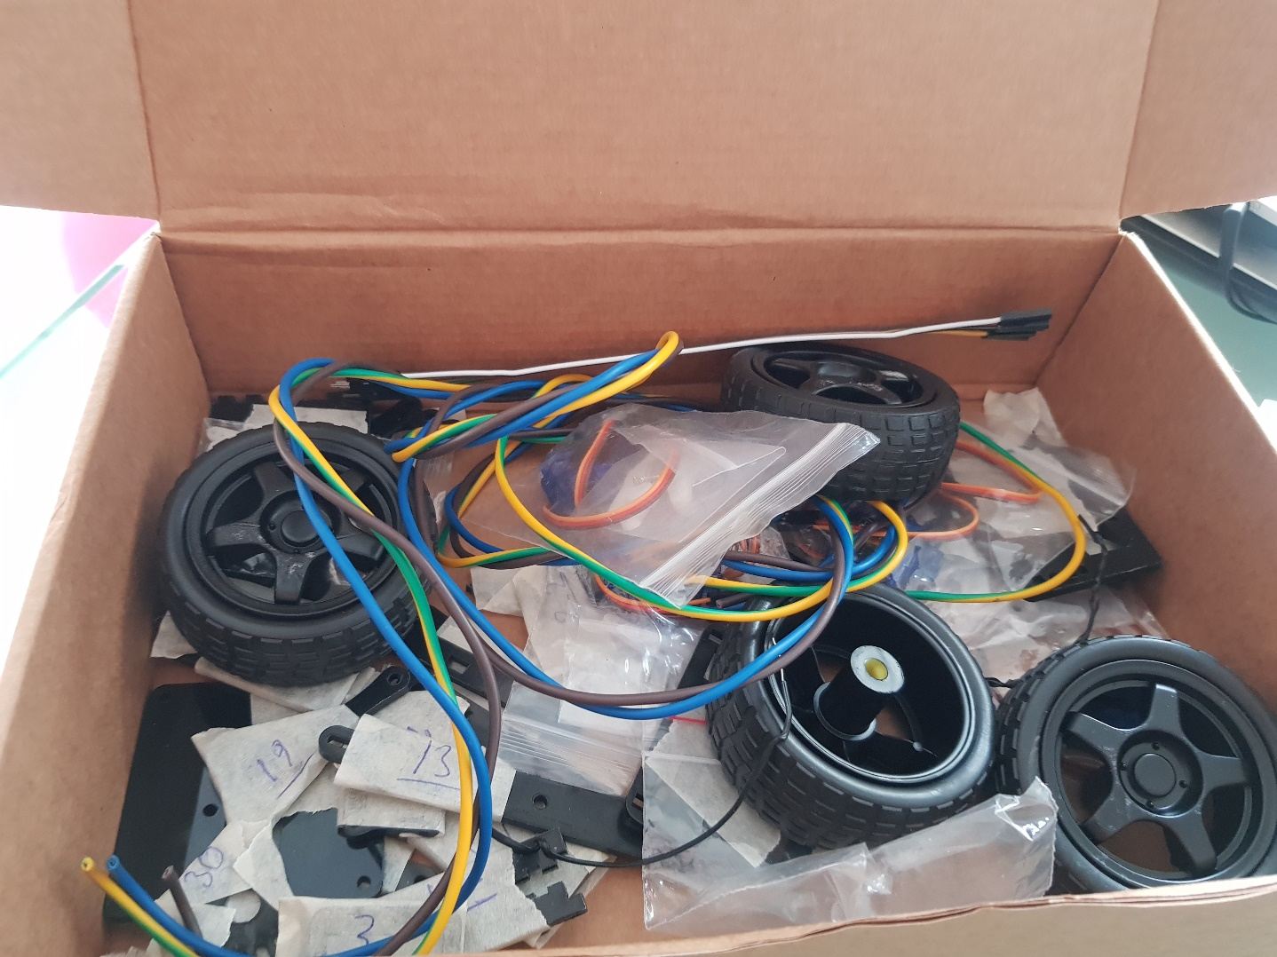

First of all I gave numbers to the parts of robot

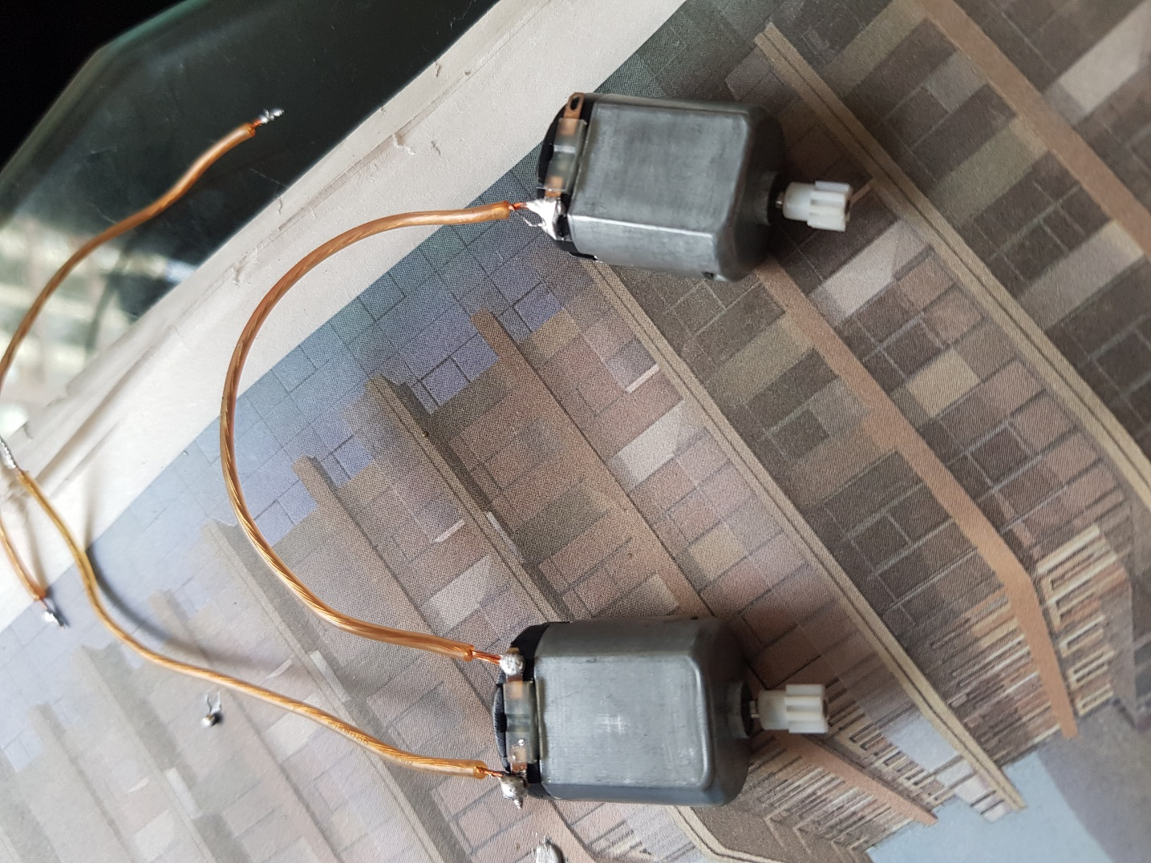

Connecting motors of robot

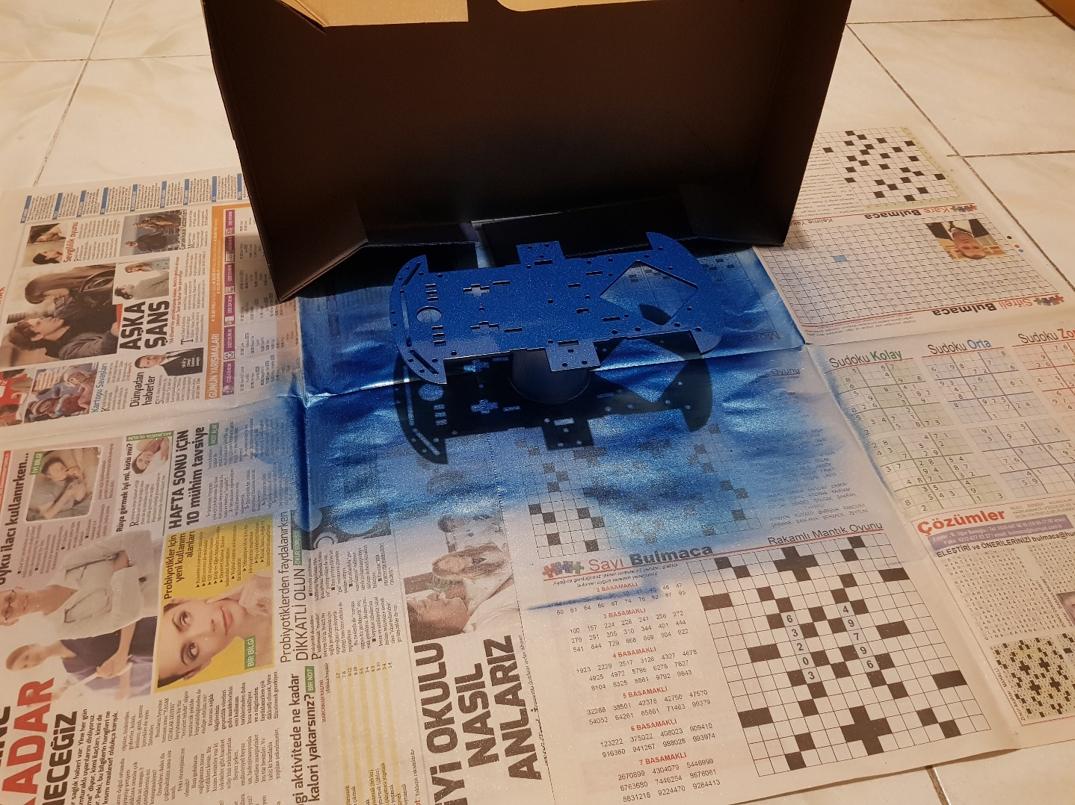

Painting of the robot body to blue color

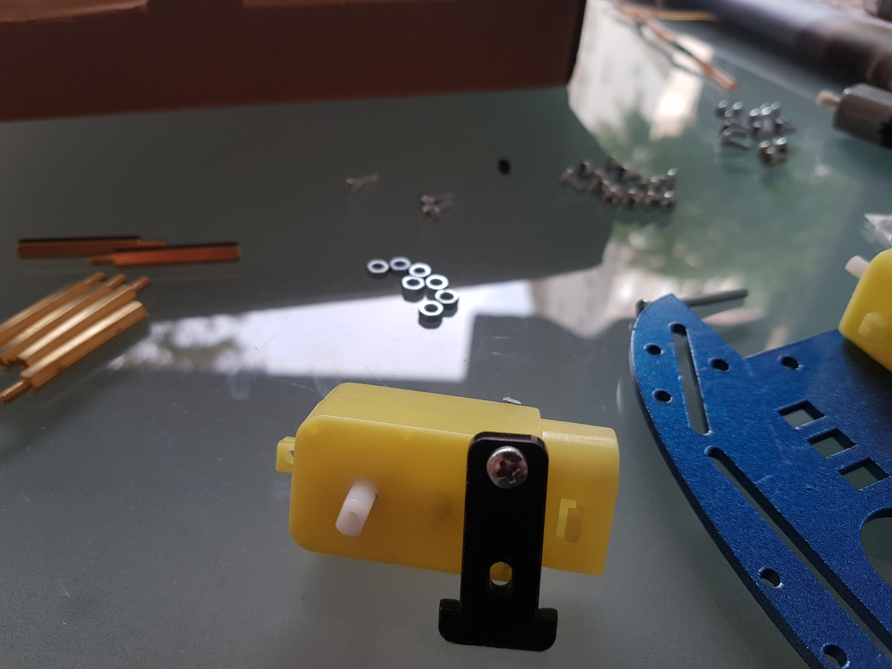

I did assembly of motor stabilizer

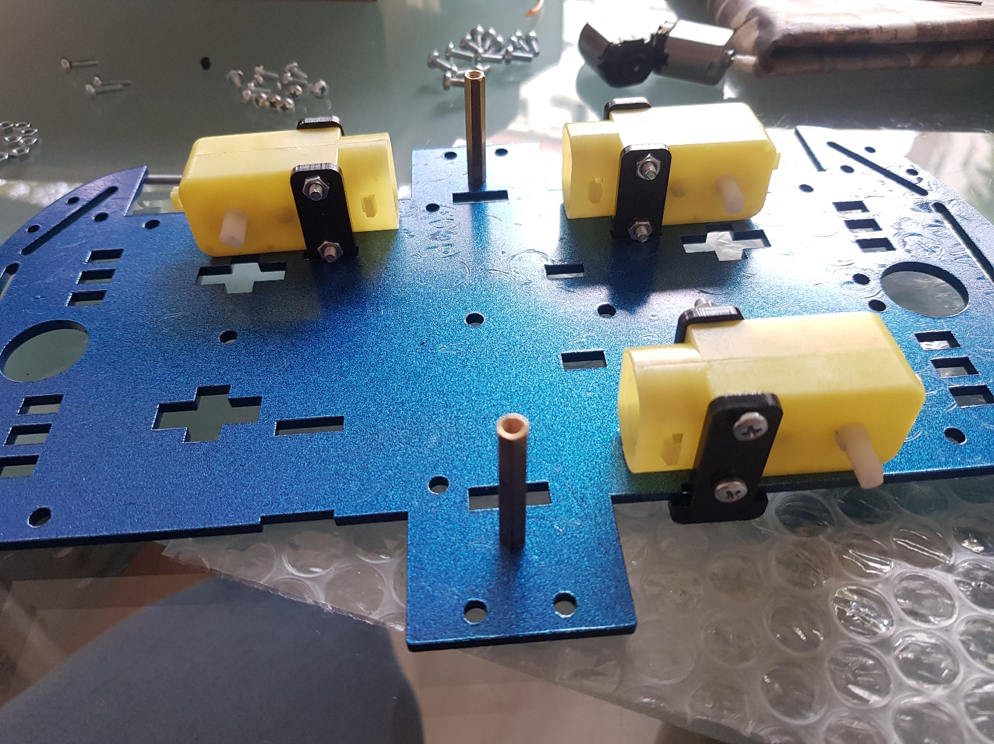

I fixed the engines

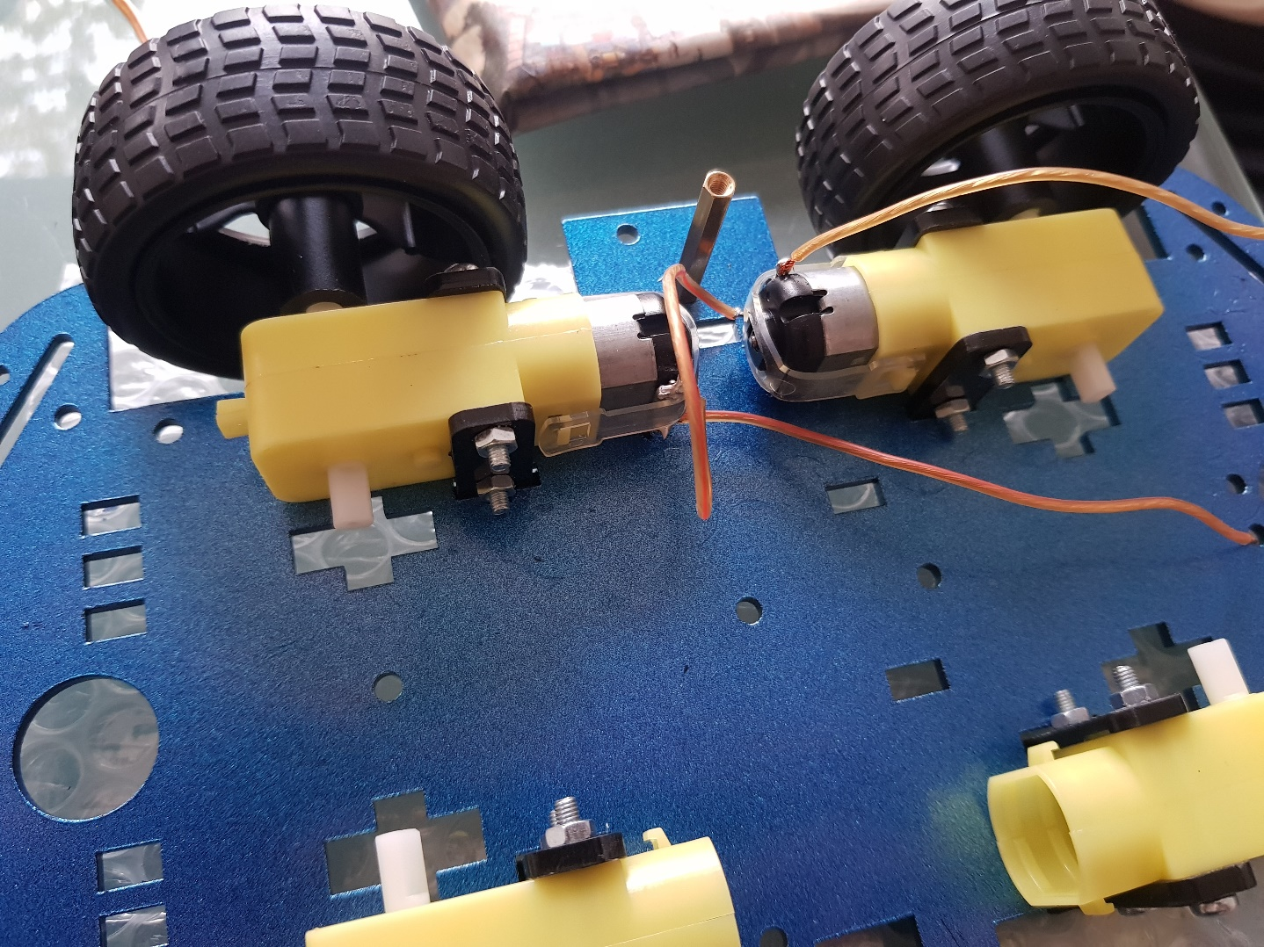

I put the wheels

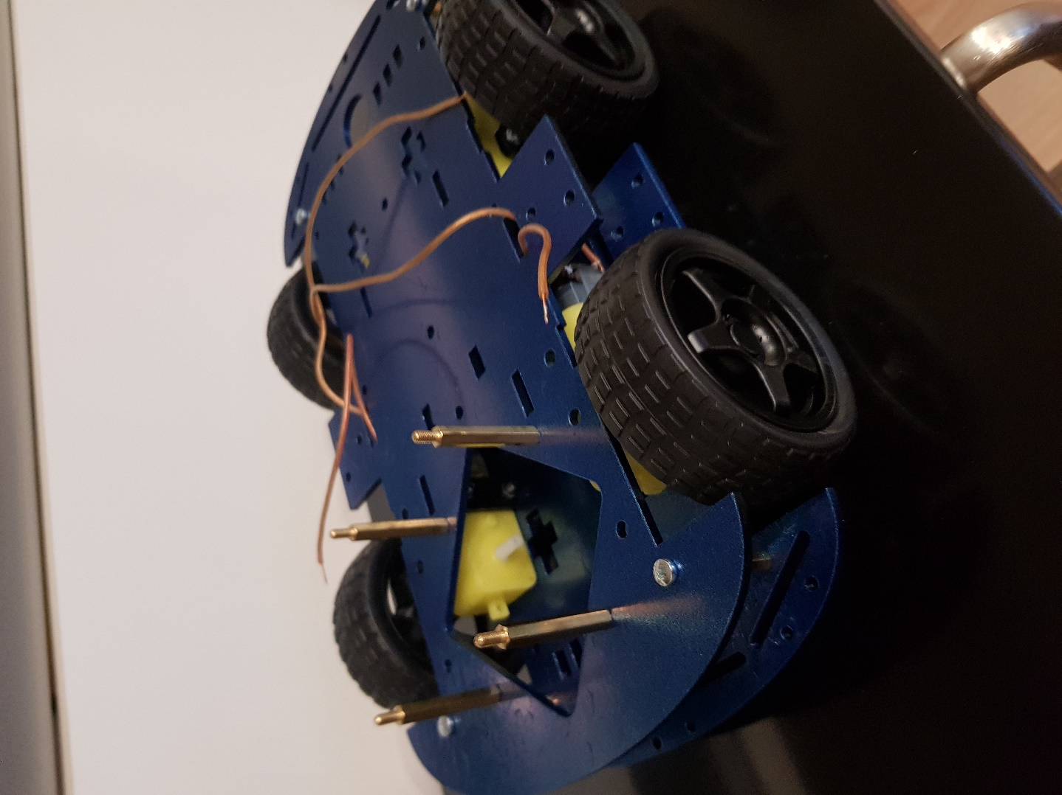

I completed ground of robot

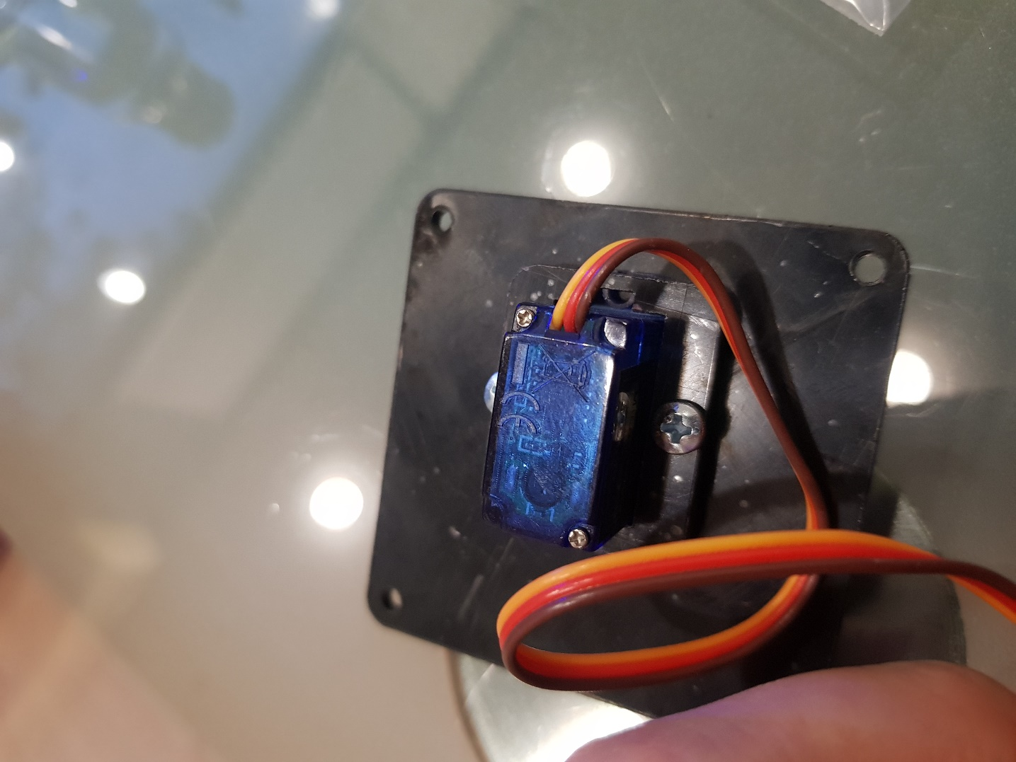

I started assembly of arm motor

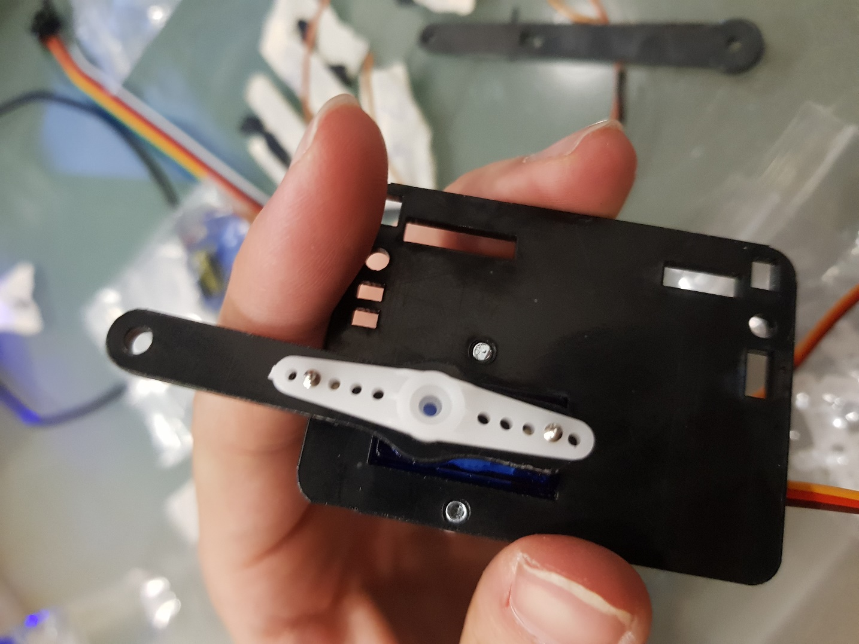

I added arm to the motor

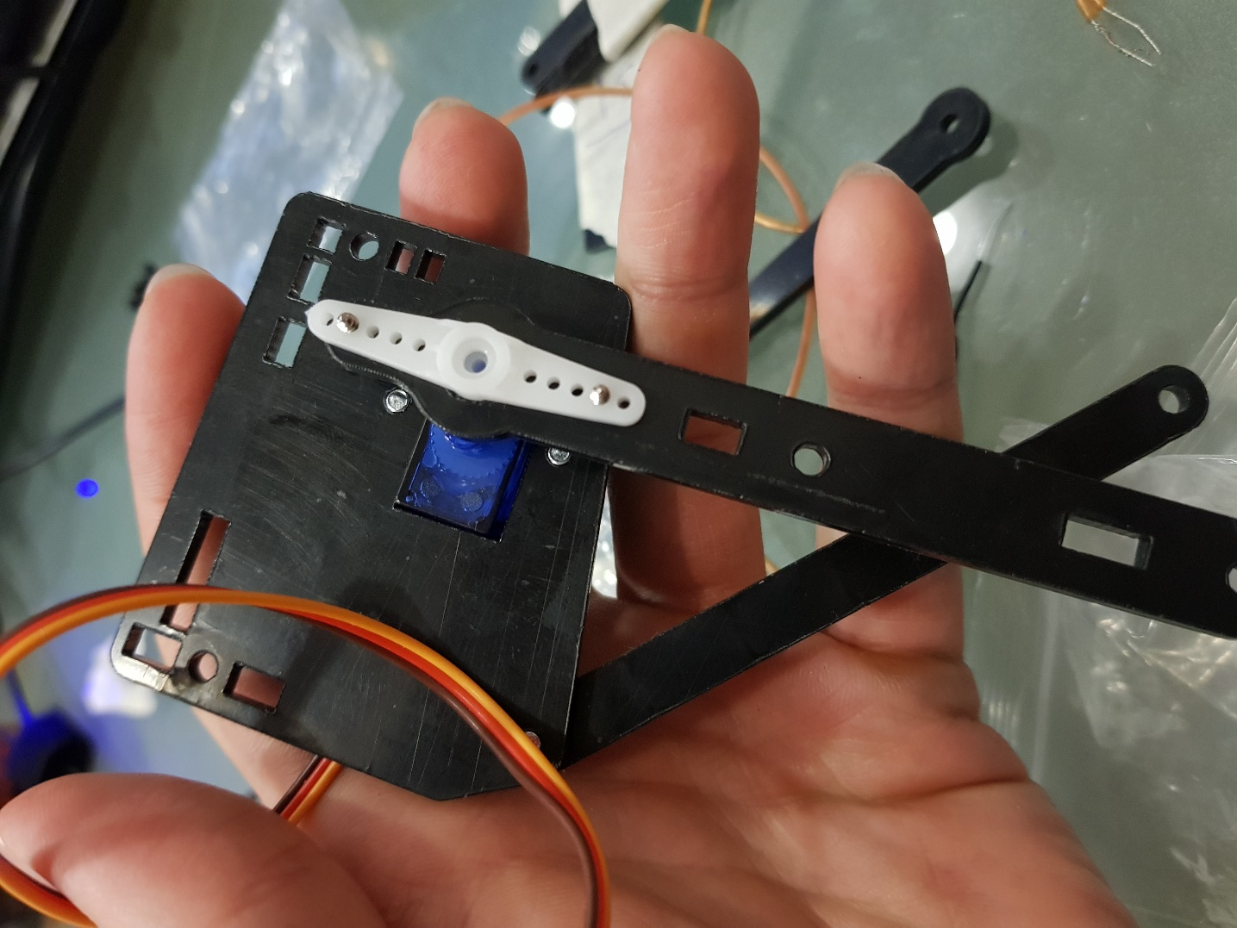

I added another arm to the motor

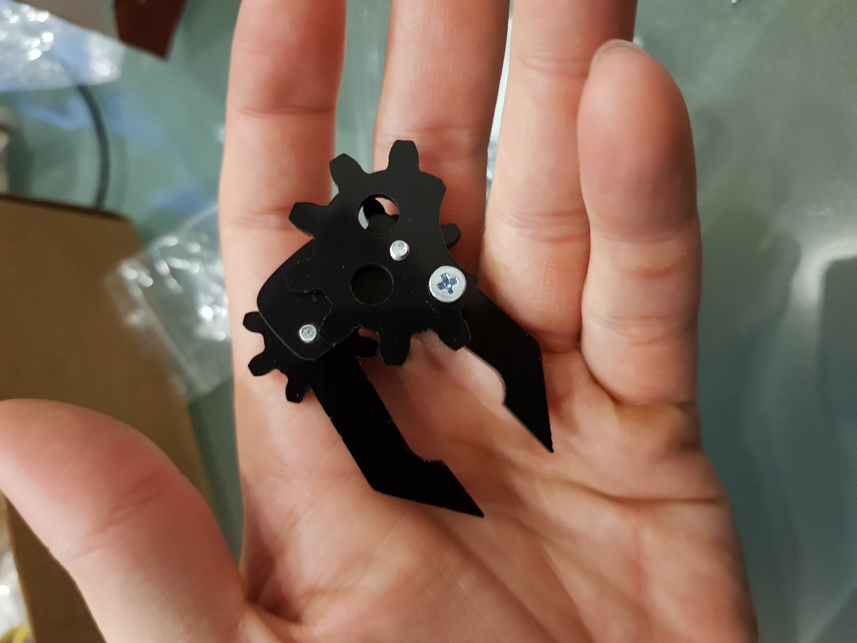

I did assembly of gripper

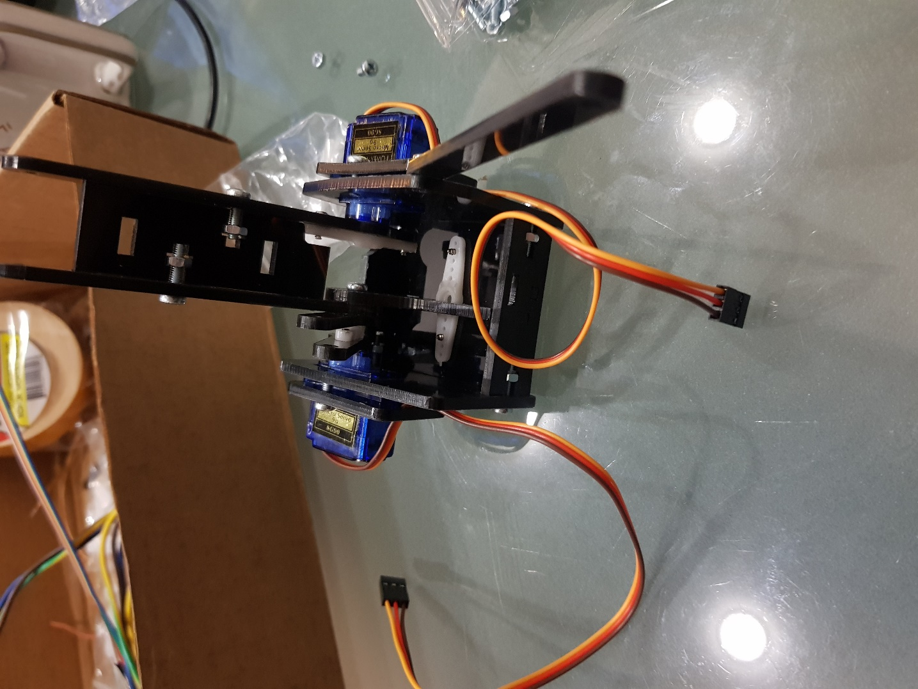

Set angle of motors

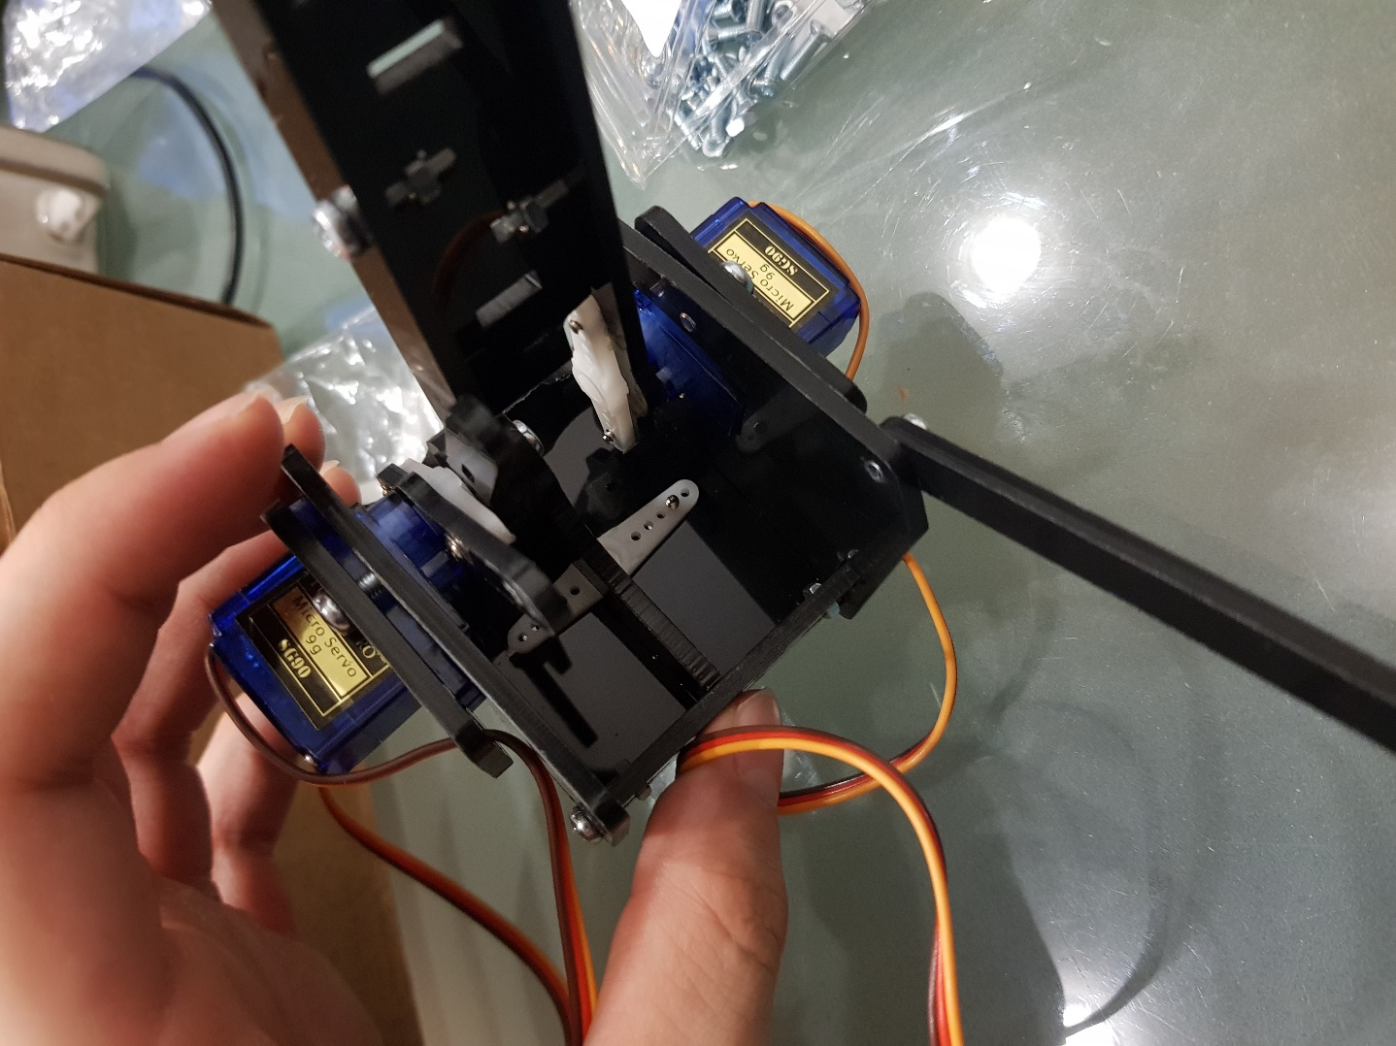

Another view of motors

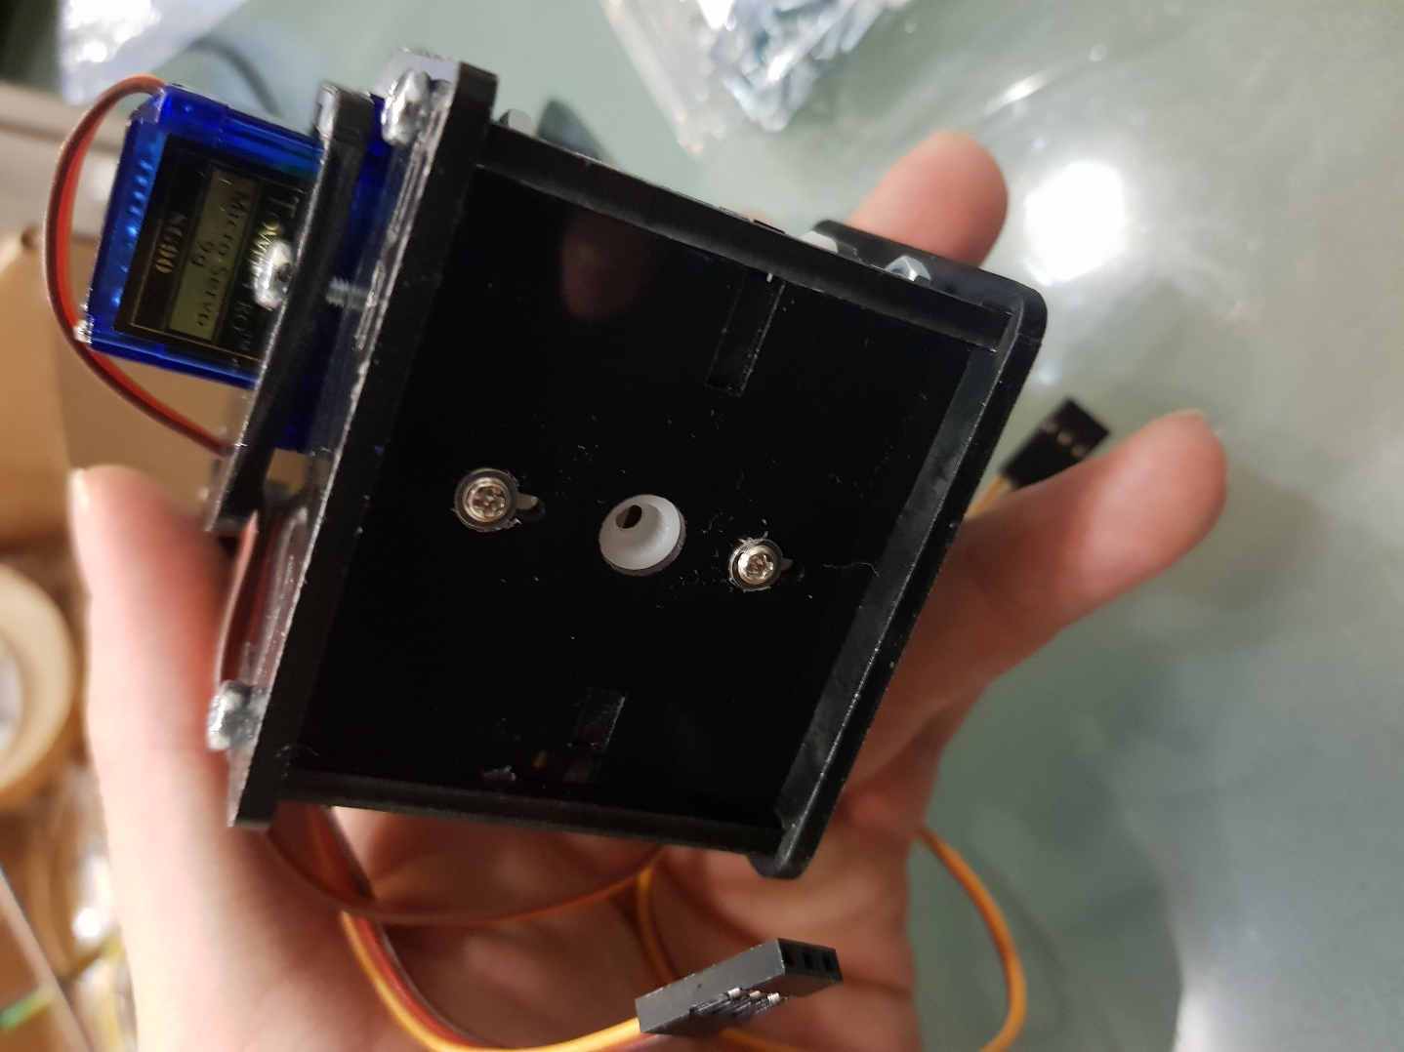

Base motor place

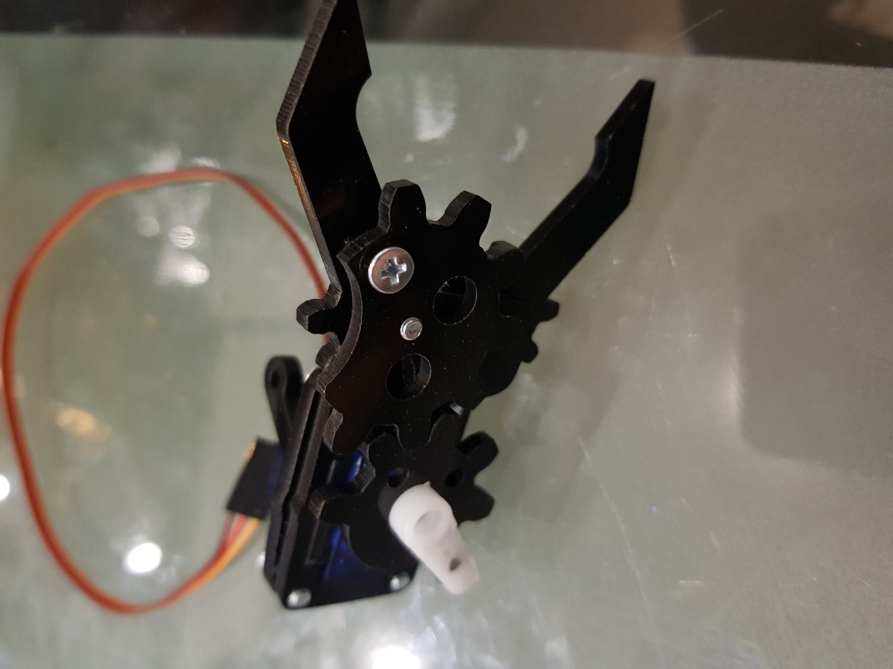

Included motor to gripper

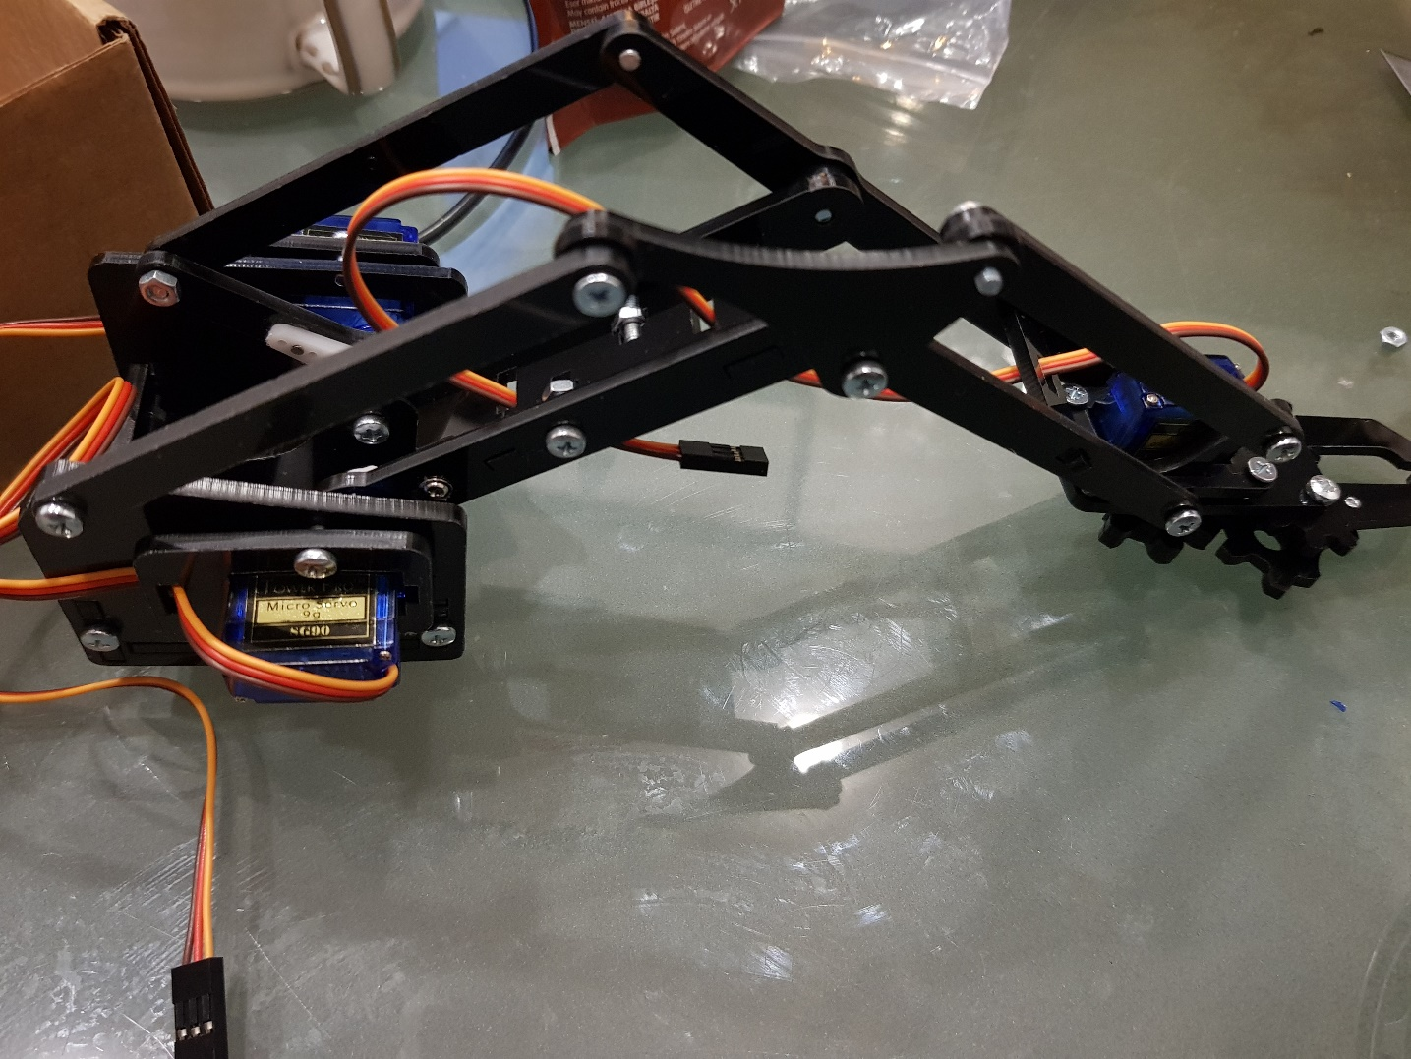

Last view of robot arm

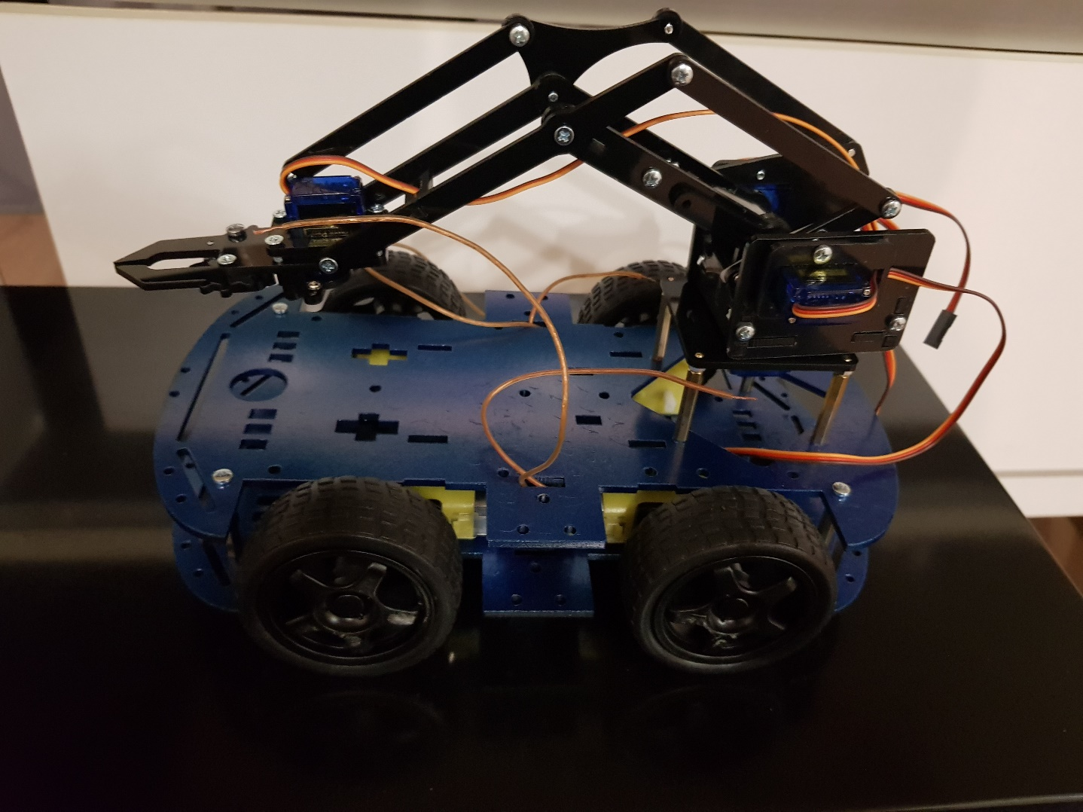

Robot arm unified with the robot ground

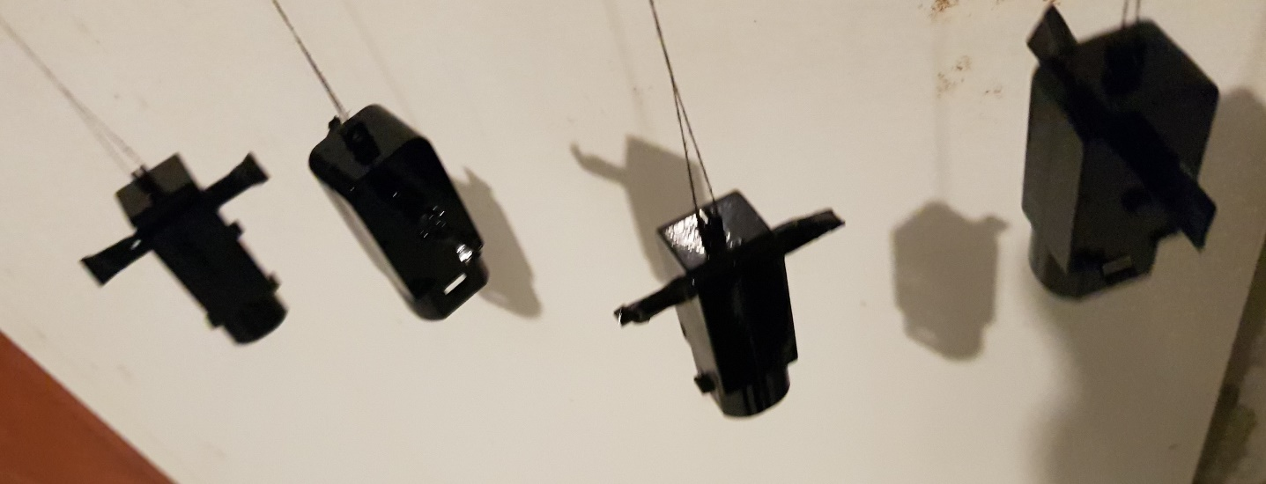

I changed colors of motor stabilizers

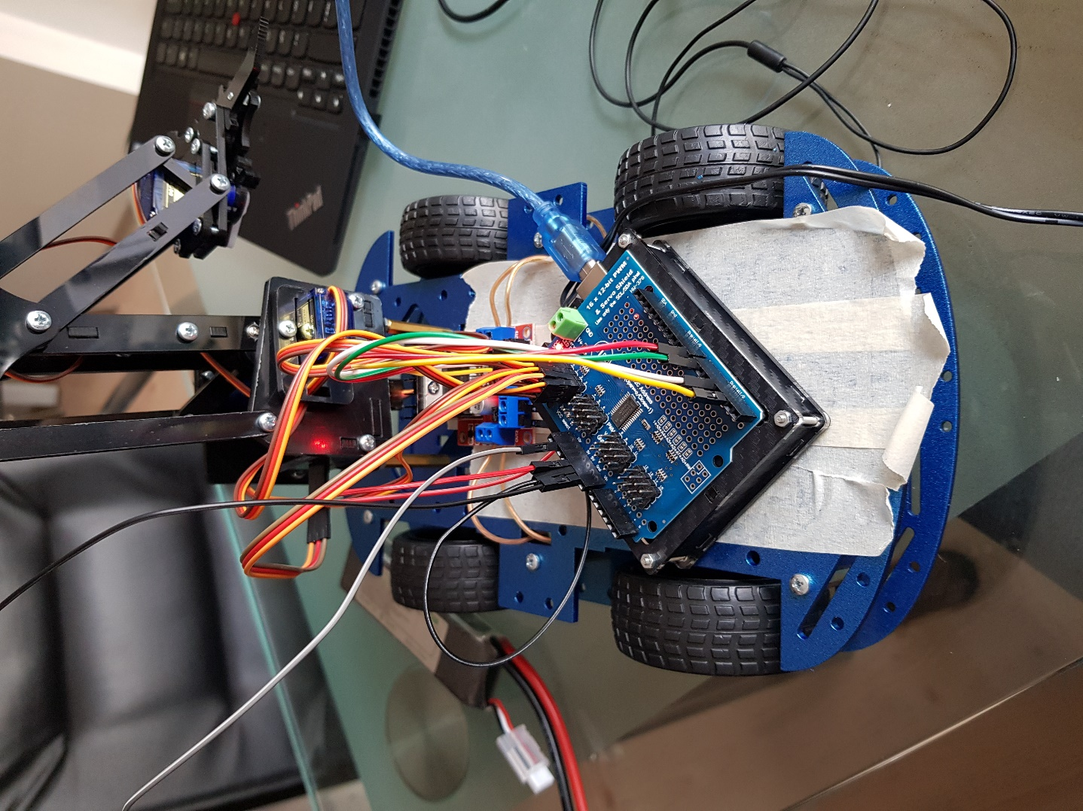

View of robot

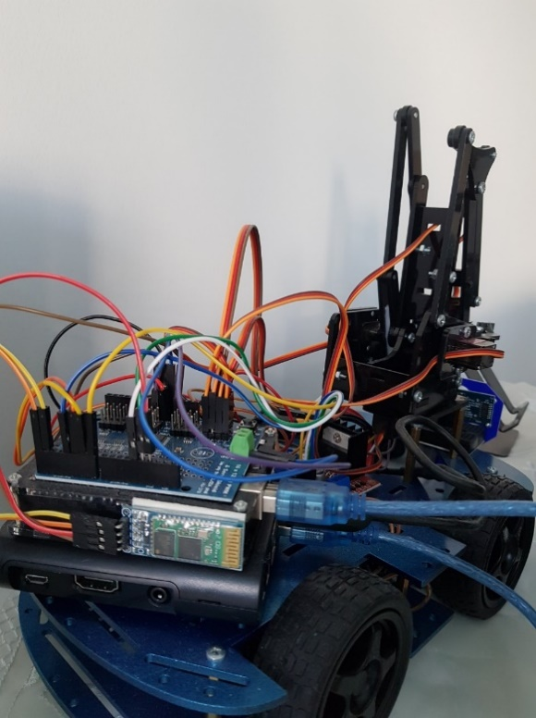

Arduino Uno, bluetooth and Raspberry PI 3 were integrated to the robot

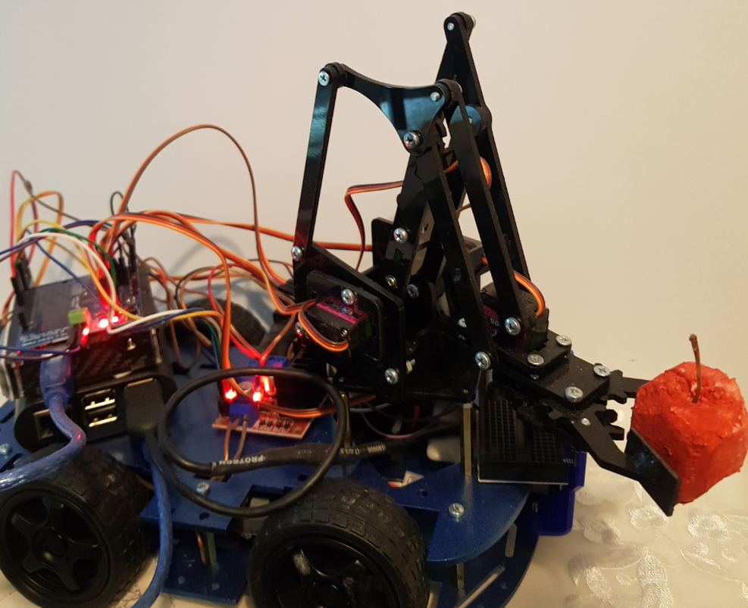

Testing grap skills

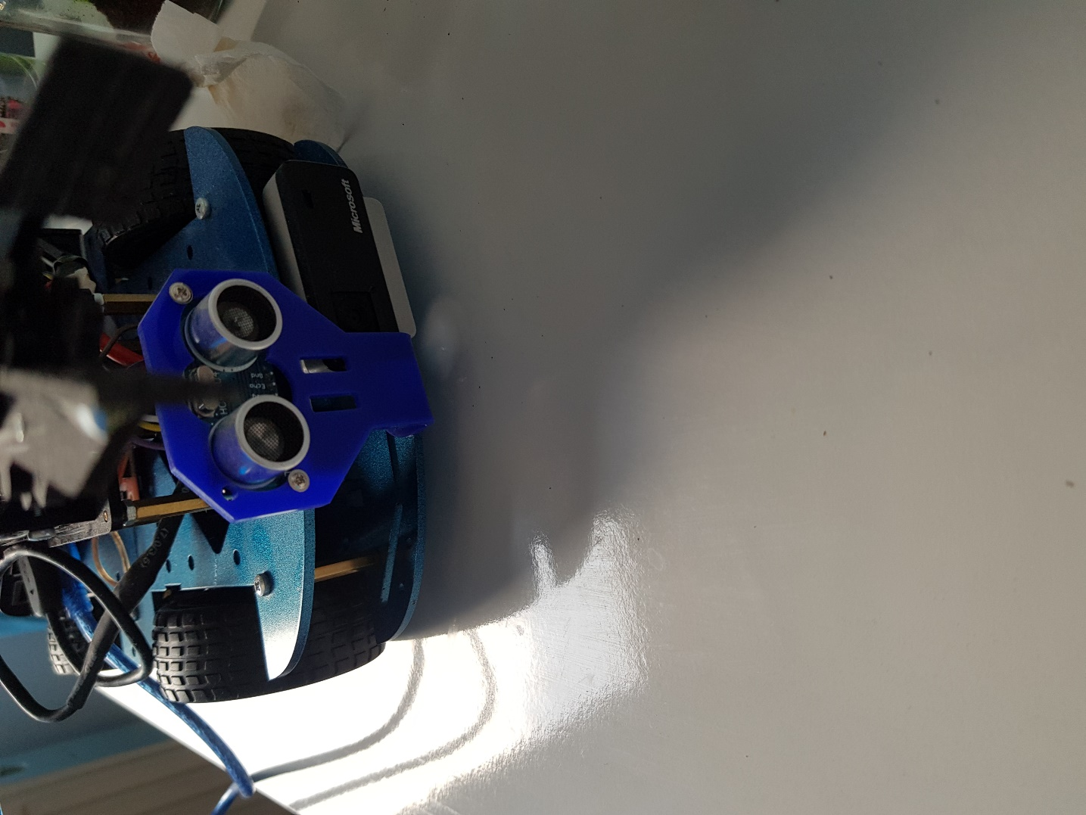

Front view of robot

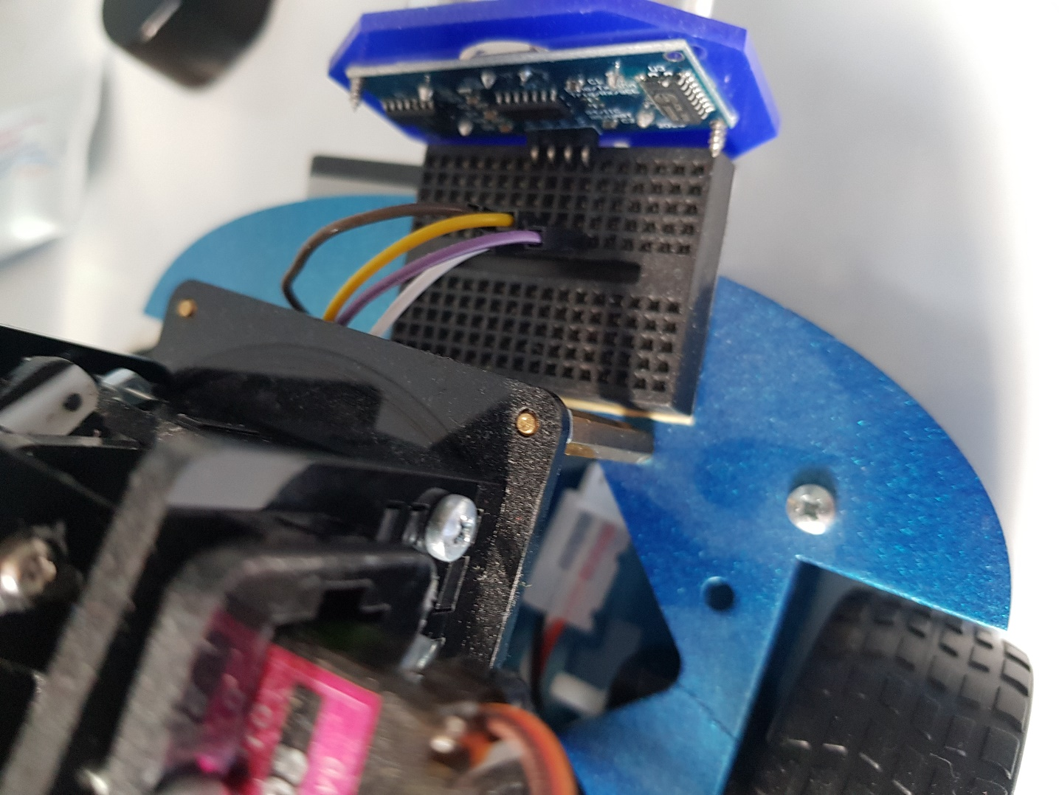

View of dashboard

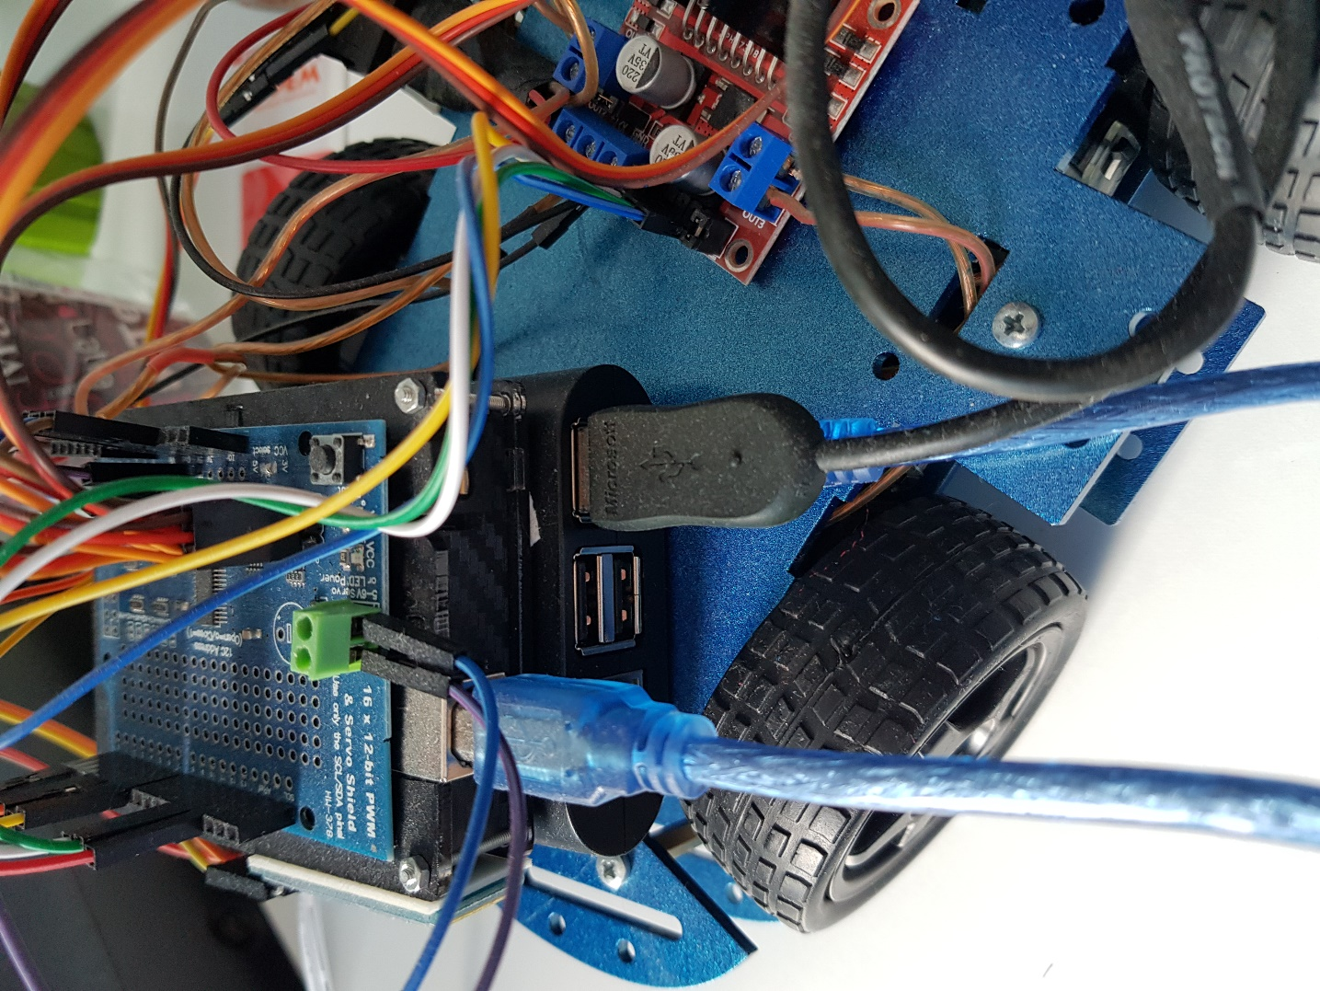

Included camera and sensor

Thanks to the wheels in the designed robot, the goal of the robot moving and changing its position achieved. Lightweight objects can be carried by grasping with the help of the added arm.